`The iWire Intercooler Splitter is designed to use the factory slots for the original hood scoop block off plate. If you no longer have the screws for that plate you can purchase them from iWire.
Installation Parts Needed:
- 9 Tapping Screws (bolts)
- 1 Body Clip
- 2 Nozzles (if you have IC Water Spray)
If all of these parts did not come with your car or you have lost them over time, you can buy them from iWire by going here - https://www.iwireservices.com/product-page/intercooler-splitter-installation-parts
WARNING! THIS SPLITTER IS DESIGNED FOR USE WITH OEM INTERCOOLERS. WITH THAT IN MIND ALL FACTORY MOUNTING BRACKETS MUST BE UTILIZED TO ENSURE THE INTERCOOLER IS SITTING IN THE CORRECT LOCATION. IF THE SPLITTER DOES NOT LINE UP PROPERLY, FIRST CHECK INTERCOOLER ALIGNMENT. OUR INTERCOOLER SPLITTER IS DESIGNED FOR STOCK STI INTERCOOLERS IN STOCK STI ENGINES. IT WILL ALSO WORK WITH WRX ENGINES WITH STI INTERCOOLERS, BUT MAY NEED A BIT OF ADJUSTMENT FOR THE CORRECT FITMENT DUE TO THE SMALL DIFFERENCES BETWEEN CUSTOM SWAPS.

Note: We've gotten the same question a few times and wanted to address it to everyone. When you remove the splitter from the box, you will notice there is a little bit of flexibility in between the backing plate and the lower gasket. This is normal and will not be a concern because as soon as you bolt the splitter to the car it will pull both pieces together for a solid base that will not rattle.
- If screws are still in the hood first remove them. 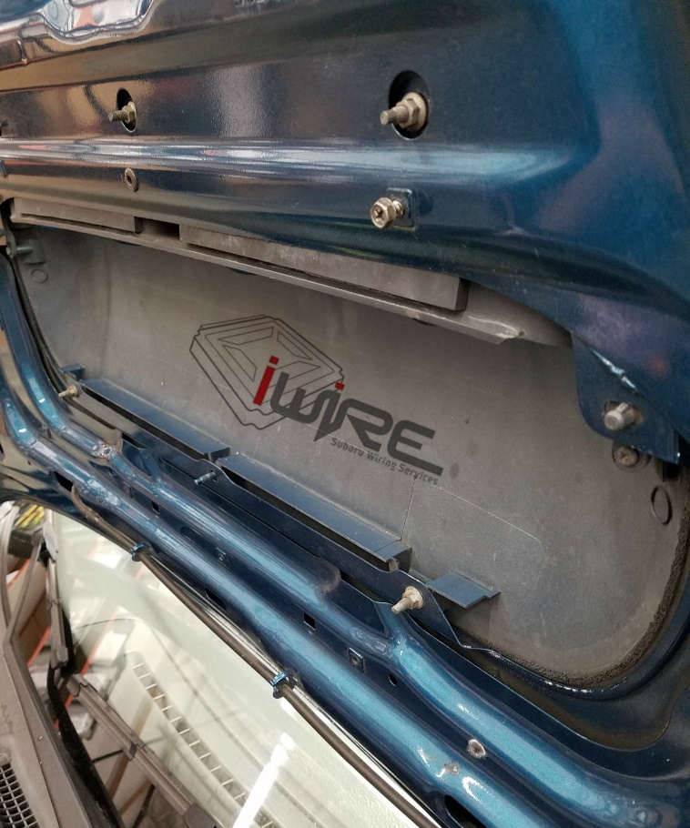

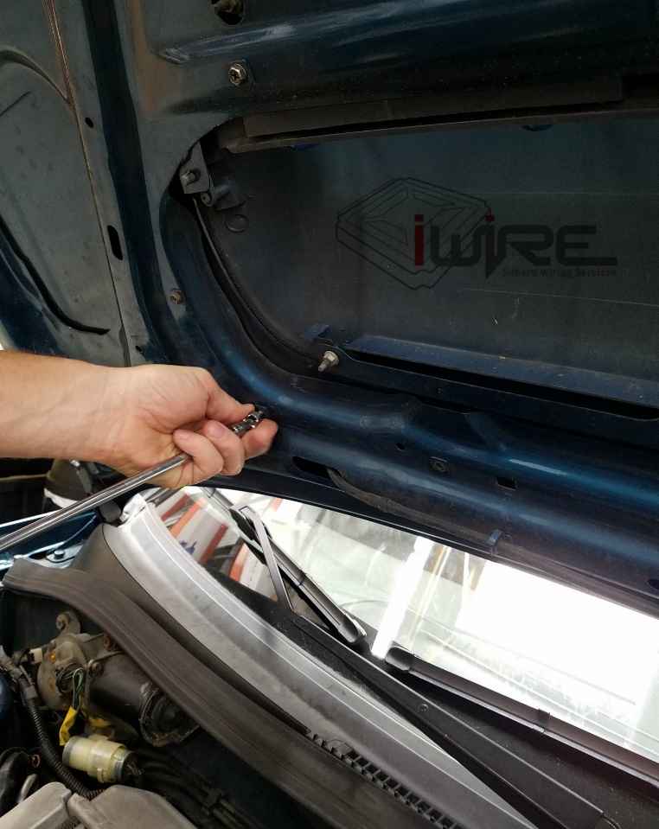
- Install splitter and line up screw holes with the the hood. 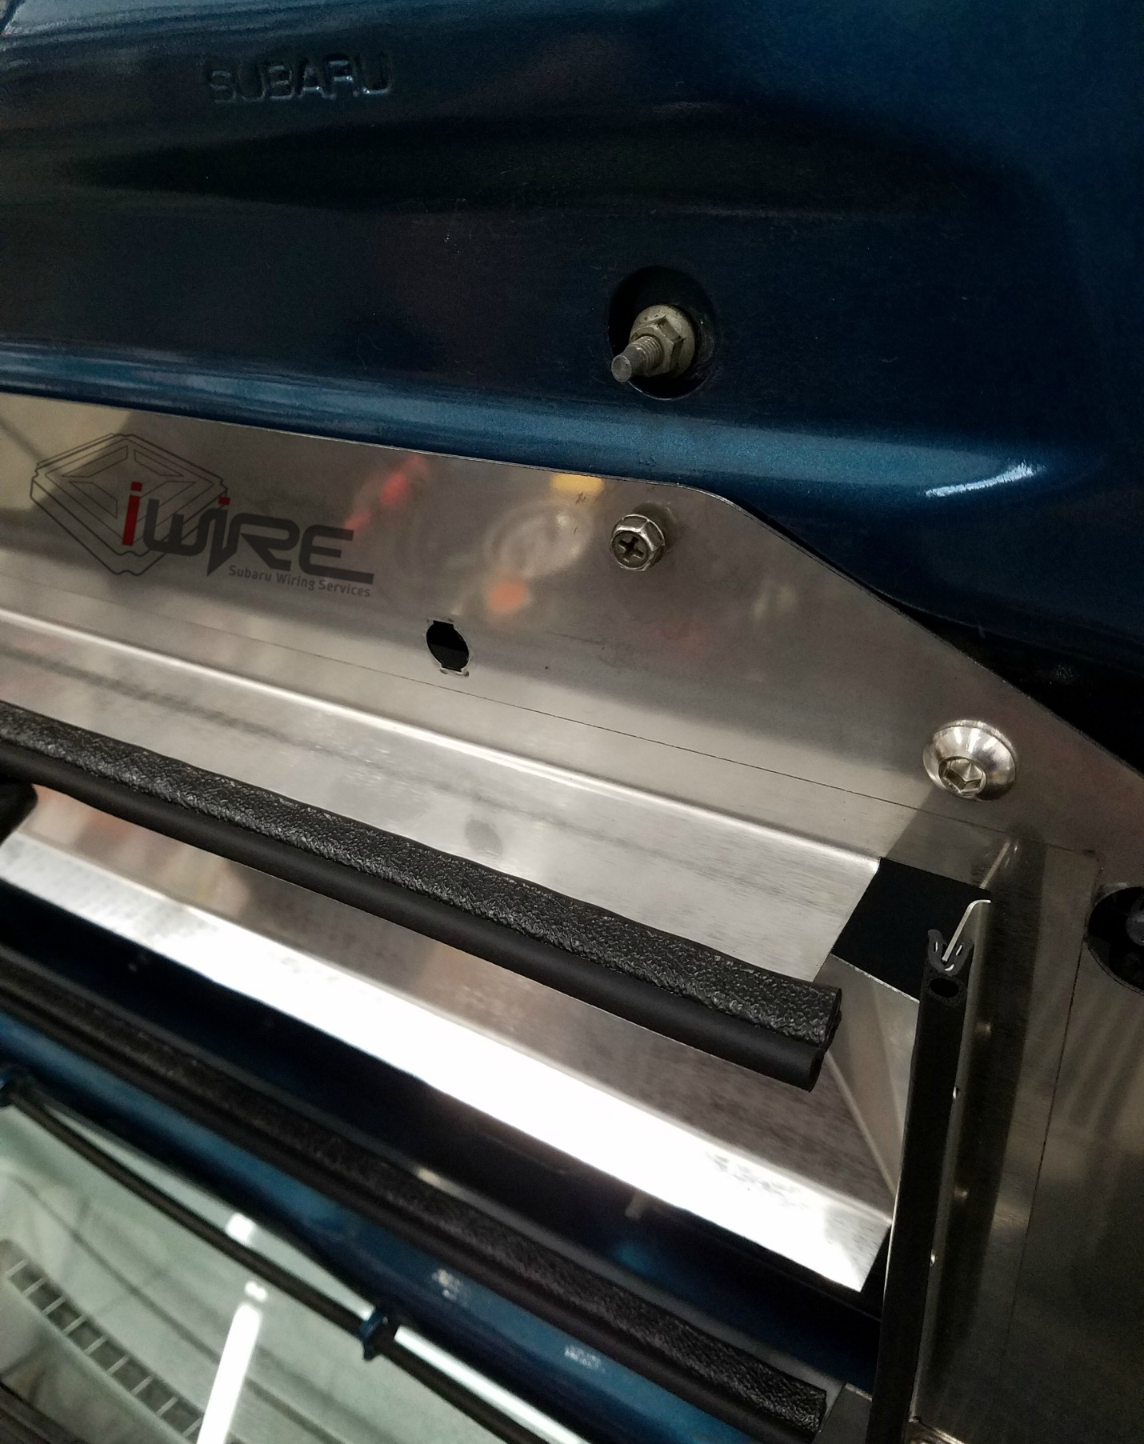

- Tighten all screws down and attach clip. Lower hood slowly to verify proper fitment. The gasket should not make contact with the intercooler itself but sit close to the fins and inside the outer housing.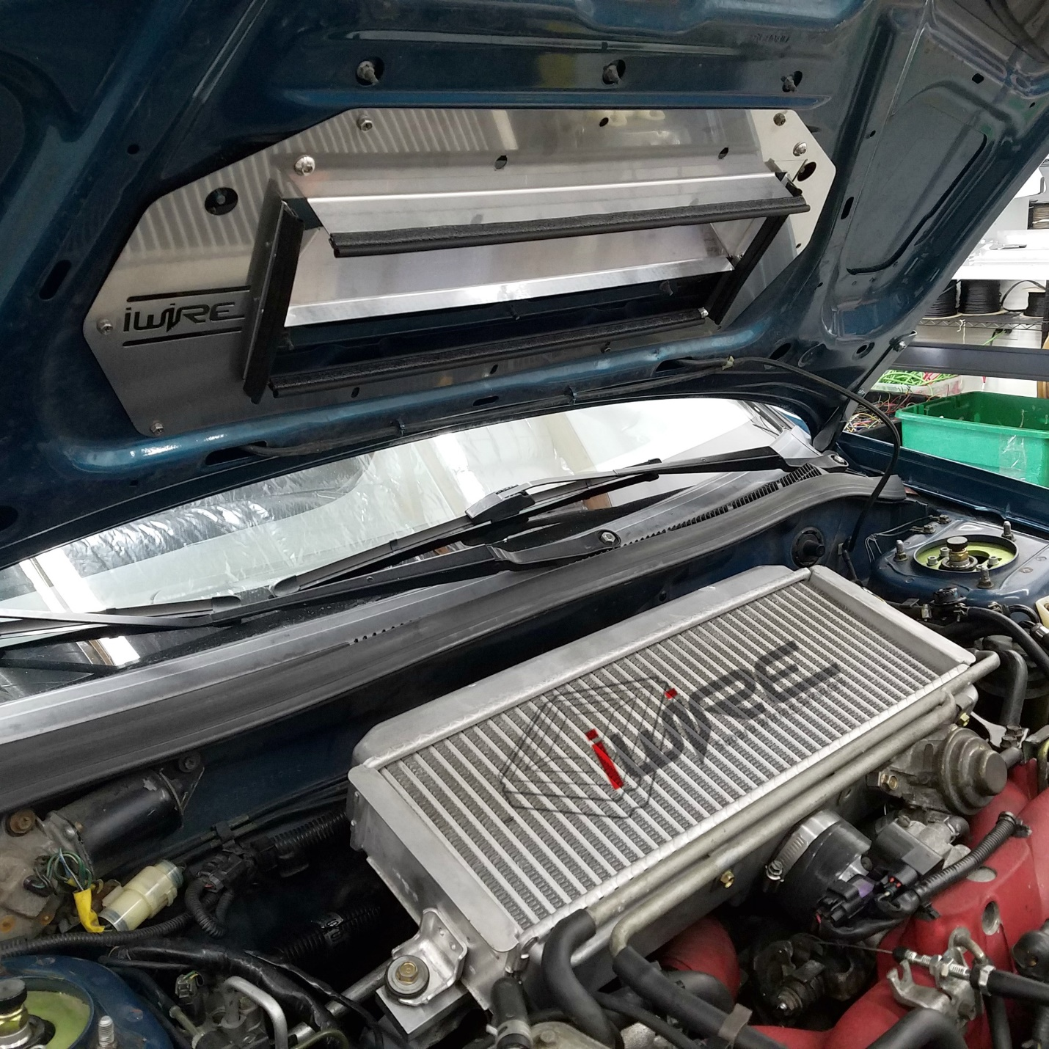
- The gasket should not make contact with the intercooler itself but sit close to the fins (but not touching) and inside the outer housing.